Ethernet Switching Basics



Huawei Technologies Co., Ltd.

|  |
| --- |
| **Copyright © Huawei Technologies Co., Ltd. 2020. All rights reserved.**  No part of this document may be reproduced or transmitted in any form or by any means without prior written consent of Huawei Technologies Co., Ltd.  **Trademarks and Permissions**  HW_POS_RBG_Vertical-150ppi.png and other Huawei trademarks are trademarks of Huawei Technologies Co., Ltd.  All other trademarks and trade names mentioned in this document are the property of their respective holders.  **Notice**  The purchased products, services and features are stipulated by the contract made between Huawei and the customer. All or part of the products, services and features described in this document may not be within the purchase scope or the usage scope. Unless otherwise specified in the contract, all statements, information, and recommendations in this document are provided "AS IS" without warranties, guarantees or representations of any kind, either express or implied.  The information in this document is subject to change without notice. Every effort has been made in the preparation of this document to ensure accuracy of the contents, but all statements, information, and recommendations in this document do not constitute a warranty of any kind, express or implied. |

|  |  |
| --- | --- |
| Huawei Technologies Co., Ltd. | |
| Address: | Huawei Industrial Base  Bantian, Longgang  Shenzhen 518129  People's Republic of China |
| Website: | <https://e.huawei.com/> |
|  |  |

**Huawei Certification System**

Huawei Certification follows the "platform + ecosystem" development strategy, which is a new collaborative architecture of ICT infrastructure based on "Cloud-Pipe-Terminal". Huawei has set up a complete certification system consisting of three categories: ICT infrastructure certification, platform and service certification, and ICT vertical certification. It is the only certification system that covers all ICT technical fields in the industry. Huawei offers three levels of certification: Huawei Certified ICT Associate (HCIA), Huawei Certified ICT Professional (HCIP), and Huawei Certified ICT Expert (HCIE). Huawei Certification covers all ICT fields and adapts to the industry trend of ICT convergence. With its leading talent development system and certification standards, it is committed to fostering new ICT talent in the digital era, and building a sound ICT talent ecosystem.

Huawei Certified ICT Associate-Datacom (HCIA-Datacom) is designed for Huawei's frontline engineers and anyone who want to understand Huawei's datacom products and technologies. The HCIA-Datacom certification covers routing and switching principles, basic WLAN principles, network security basics, network management and O&M basics, SDN and programmability and automation basics.

The Huawei certification system introduces the industry, fosters innovation, and imparts cutting-edge datacom knowledge.

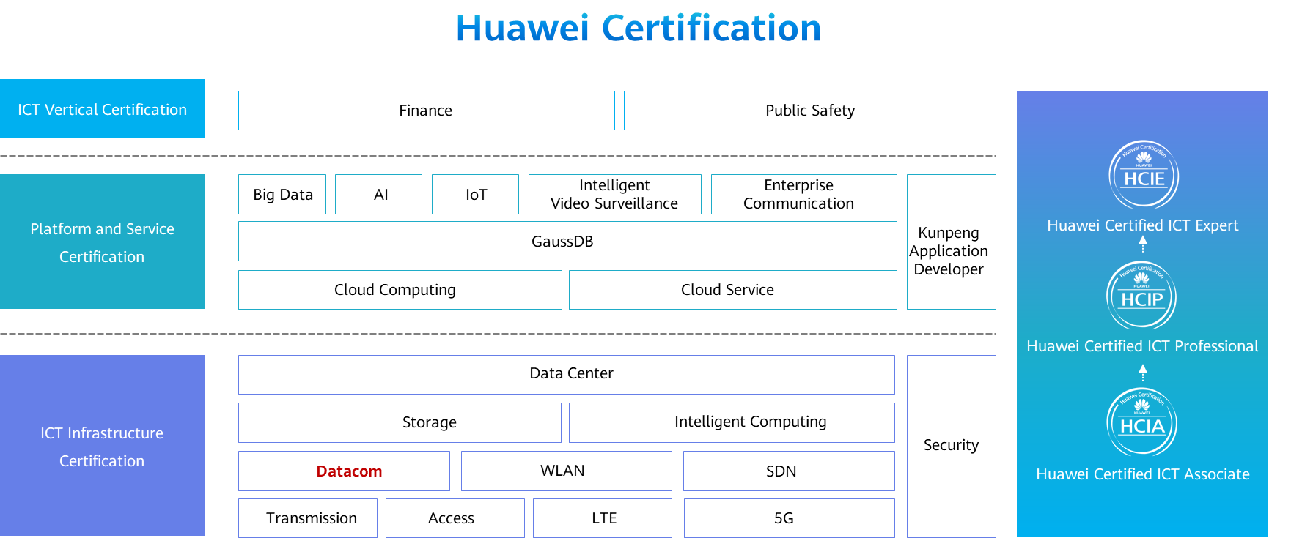

Contents

[1 Ethernet Switching Basics 1](#_Toc59715327)

[1.1 Foreword 1](#_Toc59715328)

[1.2 Objectives 1](#_Toc59715329)

[1.3 Overview of Ethernet Protocols 1](#_Toc59715330)

[1.3.1 Ethernet Protocols 1](#_Toc59715331)

[1.3.2 Collision Domain 2](#_Toc59715332)

[1.3.3 Broadcast Domain 4](#_Toc59715333)

[1.3.4 Ethernet NIC 5](#_Toc59715334)

[1.4 Overview of Ethernet Frames 5](#_Toc59715335)

[1.4.1 Ethernet Frame Format 5](#_Toc59715336)

[1.4.2 What Is a MAC Address? 7](#_Toc59715337)

[1.4.3 IP Address VS. MAC Address 7](#_Toc59715338)

[1.4.4 MAC Address Presentation 8](#_Toc59715339)

[1.4.5 MAC Address Composition and Classification 9](#_Toc59715340)

[1.4.6 Ethernet Frame 10](#_Toc59715341)

[1.5 Overview of Ethernet Switches 12](#_Toc59715342)

[1.5.1 Typical Architecture of a Campus Network 12](#_Toc59715343)

[1.5.2 Layer 2 Ethernet switch 12](#_Toc59715344)

[1.5.3 Working Principles of Switches 13](#_Toc59715345)

[1.5.4 MAC Address Table 13](#_Toc59715346)

[1.5.5 Three Frame Processing Behaviors of a Switch 14](#_Toc59715347)

[1.5.6 MAC Address Learning on a Switch 17](#_Toc59715348)

[1.6 Process of Data communication Within a Network Segment 19](#_Toc59715349)

[1.6.1 Process of Data Communication Within a Network Segment 19](#_Toc59715350)

[1.6.2 Data Encapsulation Process 20](#_Toc59715351)

[1.6.3 Initialization 20](#_Toc59715352)

[1.6.4 Flooding Frames 21](#_Toc59715353)

[1.6.5 MAC Address Learning 21](#_Toc59715354)

[1.6.6 Reply of the Target Host 22](#_Toc59715355)

[1.7 Quiz 22](#_Toc59715356)

[1.8 Summary 22](#_Toc59715357)

# Ethernet Switching Basics

## Foreword

Data transmission on networks must comply with certain standards. Ethernet protocols define how data frames are transmitted over an Ethernet network. Understanding Ethernet protocols is the basis for fully understanding communication at the data link layer. An Ethernet switch is the main device for implementing data link layer communication. It is essential to understand how an Ethernet switch works.

This course describes the concepts related to Ethernet protocols, MAC address types, and working process and mechanism of Layer 2 switches.

## Objectives

On completion of this course, you will be able to:

* Describe the basic concepts of an Ethernet network.
* Distinguish MAC address types.
* Get familiar with the working process of a Layer 2 switch.
* Get familiar with the structure and generation process of a MAC address table.

## Overview of Ethernet Protocols

### Ethernet Protocols

Ethernet is the most common communication protocol standard used by existing local area networks (LANs). It defines the cable types and signal processing methods that are used on a LAN.

An Ethernet network is a broadcast network built based on the carrier sense multiple access/collision detection (CSMA/CD) mechanism.

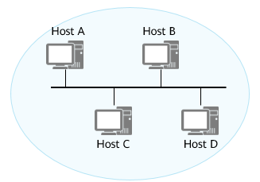

Early Ethernet

Early Ethernet:

* Ethernet networks are broadcast networks established based on the CSMA/CD mechanism. Collisions restrict Ethernet performance. Early Ethernet devices such as hubs work at the physical layer, and cannot confine collisions to a particular scope. This restricts network performance improvement.

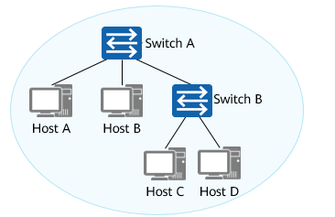

Switch Networking

Switch networking:

* Working at the data link layer, switches are able to confine collisions to a particular scope. Switches help improve Ethernet performance and have replaced hubs as mainstream Ethernet devices. However, switches do not restrict broadcast traffic on the Ethernet. This affects Ethernet performance.

### Collision Domain

A collision domain is a set of nodes connected to the same shared medium. All nodes in a collision domain compete for the same bandwidth. Packets (unicast, multicast, or broadcast) sent by a node can be received by other nodes.

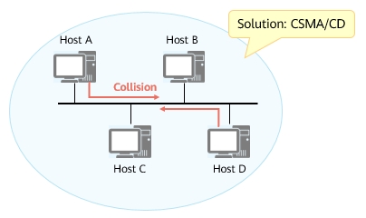

Early Ethernet: One Collision Domain

* On a traditional Ethernet network, multiple nodes on the same medium share the link bandwidth and compete for the right to use the link. As a result, collision occurs.
* The probability that collision occurs increases when more nodes are deployed on a shared medium.

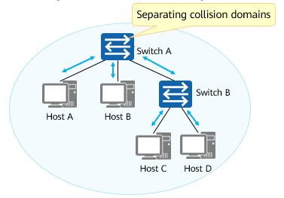

Switch Networking: Five Collision Domains

* The switch interfaces used to send and receive data are independent of each other and belong to different collision domains. Therefore, collisions do not occur between hosts (or networks) connected through switch interfaces.

On a shared network, the Ethernet uses the CSMA/CD technology to avoid collisions. The CSMA/CD process is as follows:

* A terminal continuously detects whether the shared line is idle.
  + If the line is idle, the terminal sends data.
  + If the line is in use, the terminal waits until the line becomes idle.
* If two terminals send data at the same time, a collision occurs on the line, and signals on the line become unstable.
* After detecting the instability, the terminal immediately stops sending data.
* The terminal sends a series of disturbing pulses. After a period of time, the terminal resumes the data transmission. The terminal sends disturbing pulses to inform other terminals, especially the terminal that sends data at the same time, that a collision occurred on the line.

The working principle of CSMA/CD can be summarized as follows: listen before send, listen while sending, stop sending due to collision, and resend after random delay.

### Broadcast Domain

The entire access scope of broadcast packets is called a Layer 2 broadcast domain, which is also called a broadcast domain. All hosts in the same broadcast domain can receive broadcast packets.

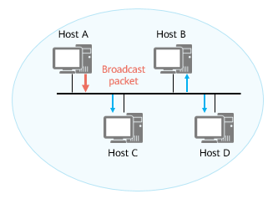

Early Ethernet: One Broadcast Domain

* On a traditional Ethernet network, multiple nodes on the same medium share a link. The broadcast packets sent by a device can be received by all the other devices.

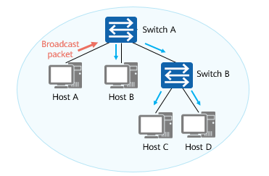

Switch Networking: One Broadcast Domain

* A switch forwards broadcast packets to all interfaces. Therefore, the nodes connected to all interfaces of the switch belong to the same broadcast domain.

An all-1 MAC address (FF-FF-FF-FF-FF-FF) is a broadcast address. All nodes process data frames with the destination address being a broadcast address. The entire access range of the data frames is called a Layer 2 broadcast domain, which is also called a broadcast domain.

Note that a MAC address uniquely identifies a network interface card (NIC). Each network adapter requires a unique MAC address.

### Ethernet NIC

A network interface card (NIC) is a key component that connects a network device (such as a computer, a switch, or a router) to an external network.

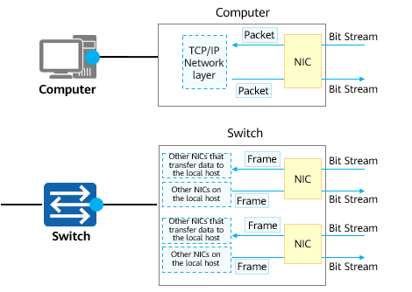

Ethernet NIC

Network Port

* A network port is also called a network interface, interface, or port.

NIC

* Each network port corresponds to a NIC.
* A computer or switch forwards data through a NIC.

There are many types of NICs. In this document, all the NICs mentioned are Ethernet NICs.

The switches mentioned in this document are Ethernet switches. The NICs used by each network port on a switch are Ethernet NICs.

## Overview of Ethernet Frames

### Ethernet Frame Format

The frames used by Ethernet technology are referred to as Ethernet frames.

Ethernet frames are in two formats: Ethernet\_II and IEEE 802.3.

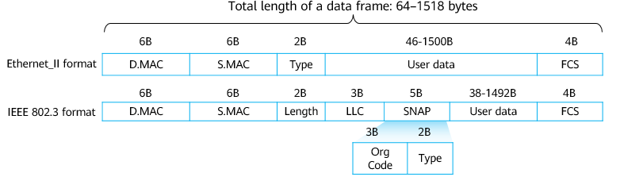

Ethernet Frame Format

Frame is the unit of data that is transmitted between network nodes on an Ethernet network. Ethernet frames are in two formats, namely, Ethernet\_II and IEEE 802.3, as illustrated in the figure shown in this slide.

Ethernet II frame:

* DMAC: 6 bytes, destination MAC address. This field identifies which MAC address should receive the frame.
* SMAC: 6 bytes, source MAC address. This field identifies which MAC address should send the frame.
* Type: 2 bytes, protocol type. Common values are as follows:
  + 0x0800: Internet Protocol Version 4 (IPv4).
  + 0x0806: Address Resolution Protocol (ARP).

IEEE 802.3 LLC Ethernet frame:

* Logical link control (LLC) consists of the destination service access point (DSAP), source service access point (SSAP), and Control field.
  + DSAP: 1 byte, destination service access point. If the subsequent type is IP, the value is set to 0x06. The function of a service access point is similar to the Type field in an Ethernet II frame or the port number in TCP/UDP.
  + SSAP: 1 byte, source service access point. If the subsequent type is IP, the value is set to 0x06.
  + Ctrl: 1 byte. This field is usually set to 0x03, indicating unnumbered IEEE 802.2 information of a connectionless service.
* The Subnetwork Access Protocol (SNAP) field consists of the Org Code field and the Type field.
  + The three bytes of the Org Code field are all 0s.
  + The Type field functions the same as that in Ethernet\_II frames.

The total length of a data frame ranges from 64 bytes to 1518 bytes. What is the reason for this design? (In addition, the MTU of an Ethernet interface is 1500 bytes.)

* On an Ethernet network, the minimum frame length is 64 bytes, which is determined jointly by the maximum transmission distance and the CSMA/CD mechanism.
  + The use of minimum frame length can prevent the following situation: station A finishes sending the last bit, but the first bit does not arrive at station B, which is far from station A. Station B considers that the line is idle and begins to send data, leading to a collision.
  + An upper-layer protocol must ensure that the Data field contains at least 46 bytes. In this way, the 14-byte Ethernet frame header and 4-byte check code at the frame tail can meet the minimum frame length of 64 bytes. If the actual data is less than 46 bytes, the upper-layer protocol must fill in certain data units.
* To achieve a tradeoff between transmission efficiency and transmission reliability, the maximum length of an Ethernet frame is 1518 bytes, and the corresponding IP data packet is 1500 bytes.
  + A large frame length improves the data transmission efficiency. However, if the data frame is too long, the transmission over the shared link takes a long time, which greatly affects delay-sensitive applications.
  + As such, a compromise data frame length of 1518 bytes is used, which corresponds to an IP data packet length of 1500 bytes. This is where the concept of MTU comes from.

### What Is a MAC Address?

A media access control (MAC) address uniquely identifies a NIC on a network. Each NIC must have a globally unique MAC address.

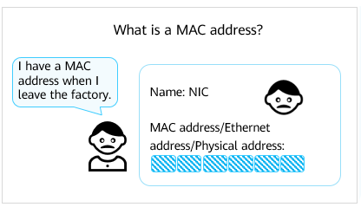

What is a MAC address?

MAC Address: Each NIC has a number, that is, a MAC address, to identify itself, just as each person has an ID card number to identify himself/herself.

A MAC address, as defined and standardized in IEEE 802, indicates the position of a network device. All Ethernet NICs that comply with the IEEE 802 standard must have a MAC address. The MAC address varies according to the NIC.

### IP Address VS. MAC Address

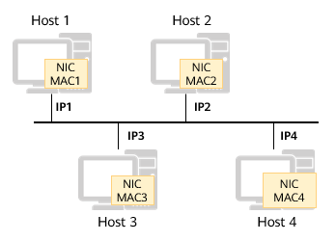

Ethernet

Each Ethernet device has a unique MAC address before delivery. When the device accesses the network, it assigns an IP address to each host. Why?

The main causes are as follows:

* IP addresses are assigned based on the network topology, and MAC addresses are assigned based on the manufacturer. If route selection is based on the manufacturer, this solution is not feasible.
* When two-layer addressing is used, devices are more flexible and easy to maintain.
  + For example, if an Ethernet NIC is faulty, you can replace it without changing its IP address. If an IP host is moved from one network to another, a new IP address can be assigned to the IP host with no need for replacing the NIC with a new one.

Characteristics of IP addresses:

* IP addresses are unique.
* IP addresses are changeable.
* IP addresses are assigned based on network topology.

Characteristics of MAC addresses:

* MAC addresses are unique.
* MAC addresses cannot be changed.
* MAC addresses are assigned based on the manufacturer.

Conclusion:

* An IP address uniquely identifies a network node. Data on different network segments can be accessed using IP addresses.
* A MAC address uniquely identifies a NIC. Data on a single network segment can be accessed using MAC addresses.

### MAC Address Presentation

A MAC address is 48 bits (6 bytes) in length.

As typically represented, MAC addresses are recognizable as six groups of two hexadecimal digits, separated by hyphens, colons, or without a separator.

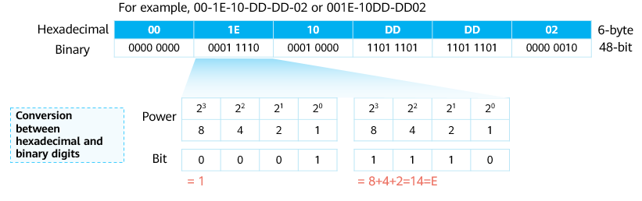

MAC Address Presentation

### MAC Address Composition and Classification



MAC address composition

Organizationally unique identifier (OUI): a 24-bit (3-byte) number. It is a globally unique identifier assigned   
by the IEEE.

Company ID (CID): a 24-bit (3-byte) number. It is assigned by a manufacturer.

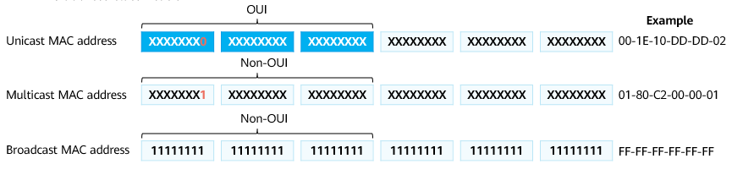

MAC address classification

A manufacturer must register with the IEEE to obtain a 24-bit (3-byte) vendor code, which is also called OUI, before producing a NIC.

The last 24 bits are assigned by a vendor and uniquely identify a NIC produced by the vendor.

MAC addresses fall into the following types:

* Unicast MAC address: is also called the physical MAC address. A unicast MAC address uniquely identifies a terminal on an Ethernet network and is a globally unique hardware address.
  + A unicast MAC address identifies a single node on a link.
  + A frame whose destination MAC address is a unicast MAC address is sent to a single node.
  + A unicast MAC address can be used as either the source or destination address.
  + Note that unicast MAC addresses are globally unique. When two terminals with the same MAC address are connected to a Layer 2 network (for example, due to incorrect operations), a communication failure occurs (for example, the two terminals fail to communicate with each other). The communication between the two terminals and other devices may also fail.
* Broadcast MAC address: an all-1 MAC address (FF-FF-FF-FF-FF-FF), which indicates all terminals on a LAN.
  + A broadcast MAC address can be considered as a special multicast MAC address.
  + The format of a broadcast MAC address is FFFF-FFFF-FFFF.
  + The frame whose destination MAC address is a broadcast MAC address is sent to all nodes on a link.
* Multicast MAC address: indicates a group of terminals on a LAN. Except for broadcast MAC addresses, all the MAC addresses with the eighth bit as 1 are multicast MAC addresses (for example, 01-00-00-00-00-00).
  + A multicast MAC address identifies a group of nodes on a link.
  + A frame whose destination MAC address is a multicast MAC address is sent to a group of nodes.
  + A multicast MAC address can only be used as the destination address but not the source address.

### Ethernet Frame

Frames on a LAN can be sent in three modes: unicast, broadcast, and multicast.

Unicast Ethernet Frame

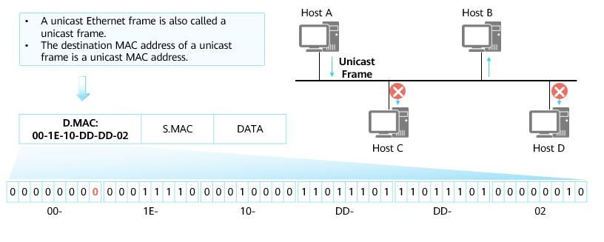

Unicast Ethernet Frame

In unicast mode, frames are sent from a single source to a single destination.

* Each host interface is uniquely identified by a MAC address. In the OUI of a MAC address, the eighth bit of the first byte indicates the address type. For a host MAC address, this bit is fixed at 0, indicating that all frames with this MAC address as the destination MAC address are sent to a unique destination.

Broadcast Ethernet Frame

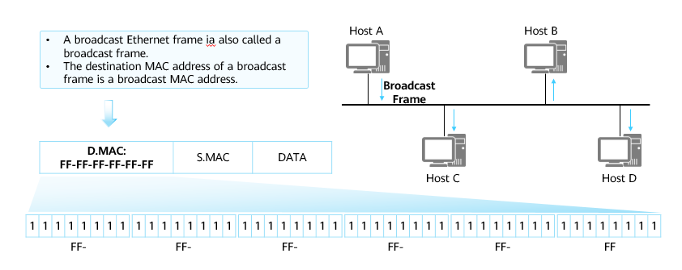

Broadcast Ethernet Frame

In broadcast mode, frames are sent from a single source to all hosts on the shared Ethernet.

* The destination MAC address of a broadcast frame is a hexadecimal address in the format of FF-FF-FF-FF-FF-FF. All hosts that receive the broadcast frame must receive and process the frame.
* In broadcast mode, a large amount of traffic is generated, which decreases the bandwidth utilization and affects the performance of the entire network.
* The broadcast mode is usually used when all hosts on a network need to receive and process the same information.

Multicast Ethernet Frame

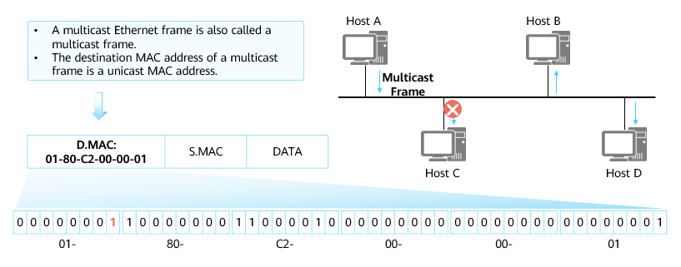

Multicast Ethernet Frame

The multicast mode is more efficient than the broadcast mode.

* Multicast forwarding can be considered as selective broadcast forwarding. Specifically, a host listens for a specific multicast address, and receives and processes frames whose destination MAC address is the multicast MAC address.
* A multicast MAC address and a unicast MAC address are distinguished by the eighth bit in the first byte. The eighth bit of a multicast MAC address is 1.
* The multicast mode is used when a group of hosts (not all hosts) on the network need to receive the same information and other hosts are not affected.

## Overview of Ethernet Switches

### Typical Architecture of a Campus Network

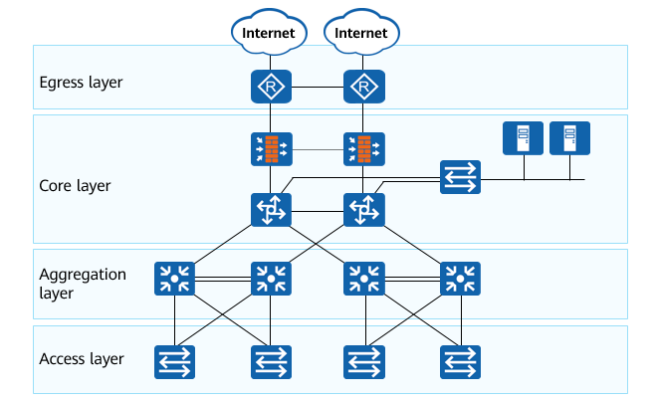

Typical architecture of a campus network

A typical campus network consists of different devices, such as routers, switches, and firewalls. Generally, a campus network adopts the multi-layer architecture which includes the access layer, aggregation layer, core layer, and egress layer.

### Layer 2 Ethernet switch

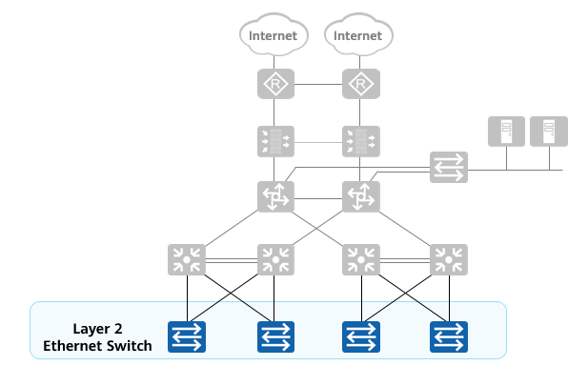

Layer 2 Ethernet switch

Layer 2 Ethernet switches forward data through Ethernet interfaces and can address and forward data only according to the MAC address in a Layer 2 header (Ethernet frame header).

Layer 2 Ethernet switch:

* On a campus network, a switch is the device closest to end users and is used to connect terminals to the campus network. Switches at the access layer are typically Layer 2 switches.
* A Layer 2 switch works at the second layer of the TCP/IP model, which is the data link layer, and forwards data packets based on MAC addresses.

Layer 3 Ethernet switch:

* Routers are required to implement network communication between different LANs. As data communication networks expand and more services emerge on the networks, increasing traffic needs to be transmitted between networks. Routers cannot adapt to this development trend because of their high costs, low forwarding performance, and small interface quantities. New devices capable of high-speed Layer 3 forwarding are required. Layer 3 switches are such devices.

Note that the switches involved in this course refer to Layer 2 Ethernet switches.

### Working Principles of Switches

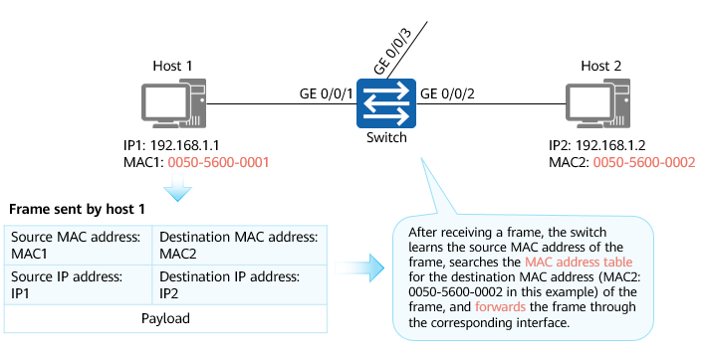

Working principles of switches

Layer 2 switches work at the data link layer and forward frames based on MAC addresses. Switch interfaces used to send and receive data are independent of each other. Each interface belongs to a different collision domain, which effectively isolates collision domains on the network.

Layer 2 switches maintain the mapping between MAC addresses and interfaces by learning the source MAC addresses of Ethernet frames. The table that stores the mapping between MAC addresses and interfaces is called a MAC address table. Layer 2 switches look up the MAC address table to determine the interface to which frames are forwarded based on the destination MAC address.

### MAC Address Table

Each switch has a MAC address table that stores the mapping between MAC addresses and switch interfaces.

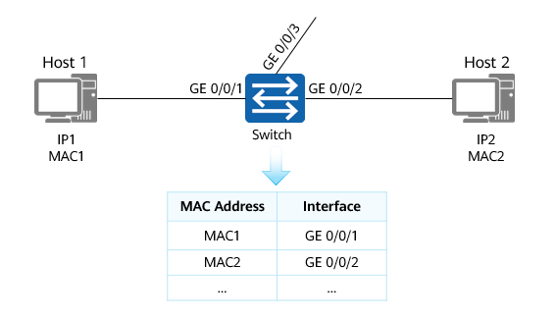

MAC address table

A MAC address table records the mapping between MAC addresses and interfaces of other devices learned by a switch. When forwarding a frame, the switch looks up the MAC address table based on the destination MAC address of the frame. If the MAC address table contains the entry corresponding to the destination MAC address of the frame, the frame is directly forwarded through the outbound interface in the entry. If the MAC address table does not contain the entry corresponding to the destination MAC address of the frame, the switch floods the frame on all interfaces except the interface that receives the frame.

### Three Frame Processing Behaviors of a Switch

A switch processes the frames entering an interface over a transmission medium in three ways:

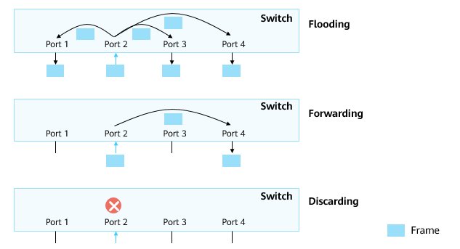

Three frame processing behaviors of a switch

A switch forwards each frame that enters an interface over a transmission medium. The basic function of a switch is to forward frames.

A switch processes frames in three ways: flooding, forwarding, and discarding.

* Flooding: The switch forwards the frames received from an interface to all other interfaces.
* Forwarding: The switch forwards the frames received from an interface to another interface.
* Discarding: The switch discards the frames received from an interface.

Flooding

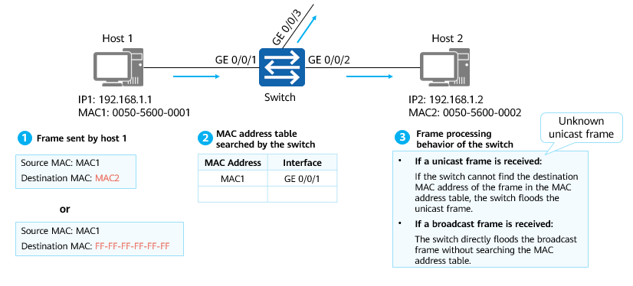

Flooding

If a unicast frame enters a switch interface over a transmission medium, the switch searches the MAC address table for the destination MAC address of the frame. If the MAC address cannot be found, the switch floods the unicast frame.

If a broadcast frame enters a switch interface over a transmission medium, the switch directly floods the broadcast frame instead of searching the MAC address table for the destination MAC address of the frame.

As shown in this figure:

* Scenario 1: Host 1 wants to access host 2 and sends a unicast frame to the switch. After receiving the unicast frame, the switch searches the MAC address table for the destination MAC address of the frame. If the destination MAC address does not exist in the table, the switch floods the frame.
* Scenario 2: Host 1 wants to access host 2 but does not know the MAC address of host 2. Host 1 sends an ARP Request packet, which is a broadcast frame to the switch. The switch then floods the broadcast frame.

Forwarding

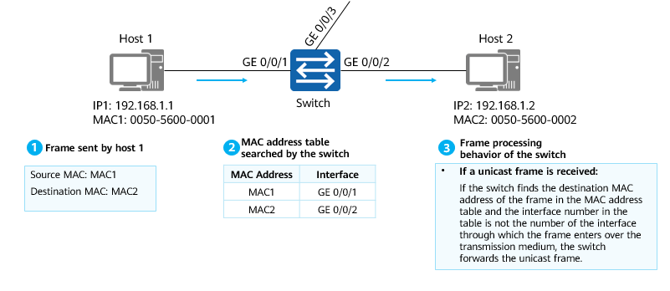

Forwarding

If a unicast frame enters a switch interface over a transmission medium, the switch searches the MAC address table for the destination MAC address of the frame. If the corresponding entry is found in the MAC address table, the switch checks whether the interface number corresponding to the destination MAC address is the number of the interface through which the frame enters the switch over the transmission medium. If not, the switch forwards the frame to the interface corresponding to the destination MAC address of the frame in the MAC address table. The frame is then sent out from this interface.

As shown in this figure,

* Host 1 wants to access host 2 and sends a unicast frame to the switch. After receiving the unicast frame, the switch finds the corresponding entry in the MAC address table and forwards the frame in point-to-point mode.

Discarding

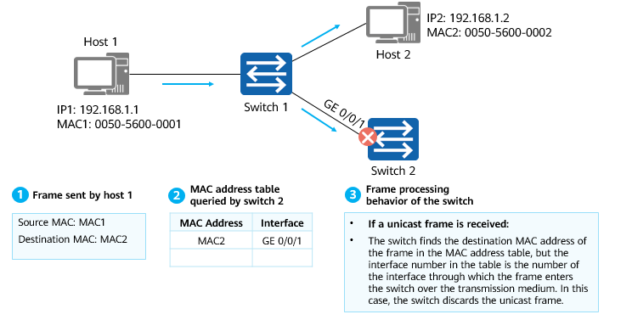

Discarding

If a unicast frame enters a switch interface over a transmission medium, the switch searches the MAC address table for the destination MAC address of the frame. If the corresponding entry is found in the MAC address table, the switch checks whether the interface number corresponding to the destination MAC address in the MAC address table is the number of the interface through which the frame enters the switch over the transmission medium. If yes, the switch discards the frame.

As shown in this figure:

* Host 1 wants to access host 2 and sends a unicast frame to switch 1. After receiving the unicast frame, switch 1 searches the MAC address table for the destination MAC address of the frame. If the destination MAC address does not exist in the table, switch 1 floods the frame.
* After receiving the frame, switch 2 finds that the interface corresponding to the destination MAC address is the interface that receives the frame. In this case, switch 2 discards the frame.

### MAC Address Learning on a Switch

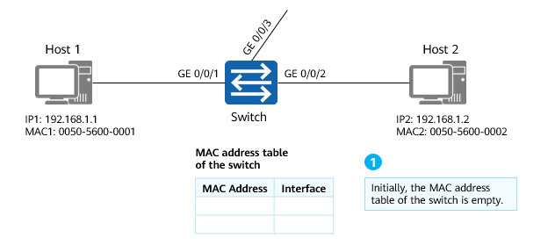

MAC address learning on a switch (1)

* In the initial state, a switch does not know the MAC address of a connected host. Therefore, the MAC address table is empty.

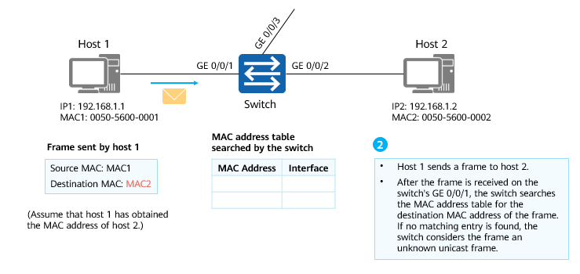

MAC address learning on a switch (2)

* If host 1 wants to send data to host 2 (assume that host 1 has obtained the IP address and MAC address of host 2), host 1 encapsulates the frame with its own source IP address and source MAC address.
* After receiving the frame, the switch searches its own MAC address table. If no matching entry is found in the table, the switch considers the frame an unknown unicast frame.

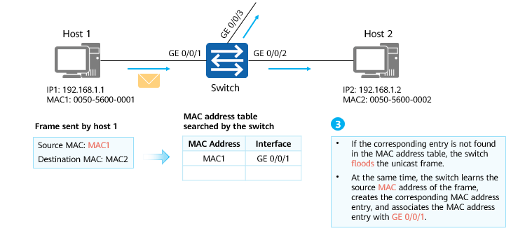

MAC address learning on a switch (3)

* The switch floods the received frame because it is an unknown unicast frame.
* In addition, the switch records the source MAC address and interface number of the received frame in the MAC address table.
* Note that the dynamically learned entries in a MAC address table are not always valid. Each entry has a lifespan. If an entry is not updated within the lifespan, the entry will be deleted. This lifespan is called the aging time. For example, the default aging time of Huawei S series switches is 300s.

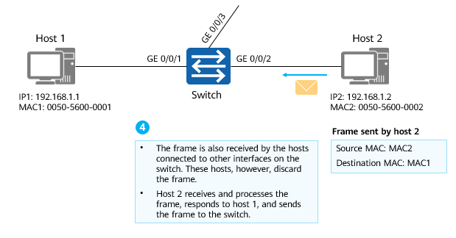

MAC address learning on a switch (4)

* All hosts on a broadcast network receive the frame, but only host 2 processes the frame because the destination MAC address is the MAC address of host 2.
* Host 2 sends a reply frame, which is also a unicast data frame, to host 1.

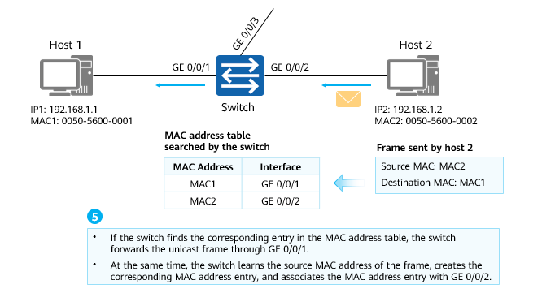

MAC address learning on a switch (5)

* After receiving the unicast frame, the switch checks its MAC address table. If a matching entry is found, the switch forwards the frame through the corresponding interface.
* In addition, the switch records the source MAC address and interface number of the received frame in the MAC address table.

## Process of Data communication Within a Network Segment

### Process of Data Communication Within a Network Segment

Scenario description:

* Task: Host 1 wants to access host 2.
* Host: The host is in the initialized state and only knows its own IP address and MAC address (assume that the IP address of the peer host has been obtained).
* Switch: The switch is just powered on and in the initialized state.

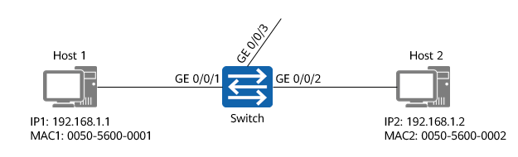

Process of data communication within a network segment

### Data Encapsulation Process

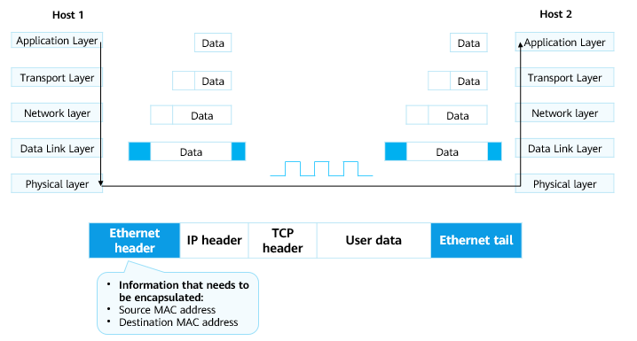

Data encapsulation process

Before sending a packet, host 1 needs to encapsulate information, including the source and destination IP addresses and the source and destination MAC addresses, into the packet.

### Initialization

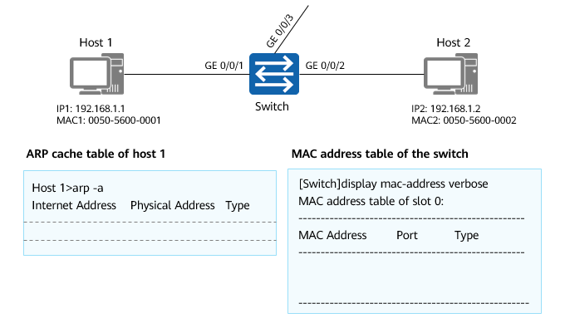

Initialization

To encapsulate packet, host 1 searches the local ARP cache table. In the initial state, the ARP cache table of host 1 is empty.

For the switch that is just powered on, in the initial state, the MAC address table is also empty.

### Flooding Frames

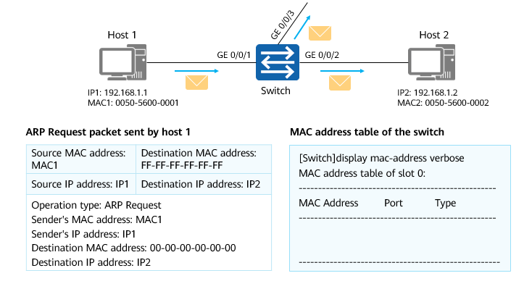

Flooding frames

Host 1 sends an ARP Request packet to request for the destination MAC address.

After receiving a frame, the switch searches the MAC address table. If no matching entry is found in the table, the switch floods the frame to other interfaces other than the interface receiving the frame.

### MAC Address Learning

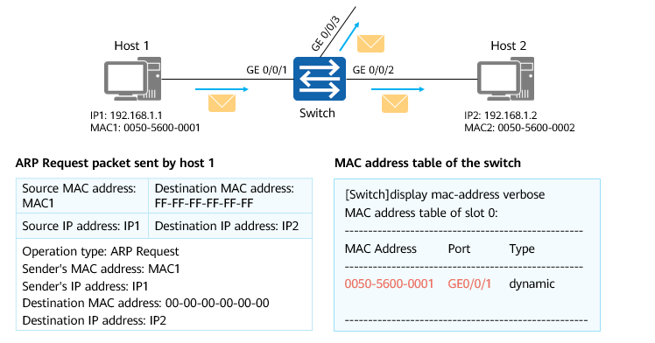

MAC address learning

The switch records the source MAC address and interface number of the received frame in the MAC address table.

### Reply of the Target Host

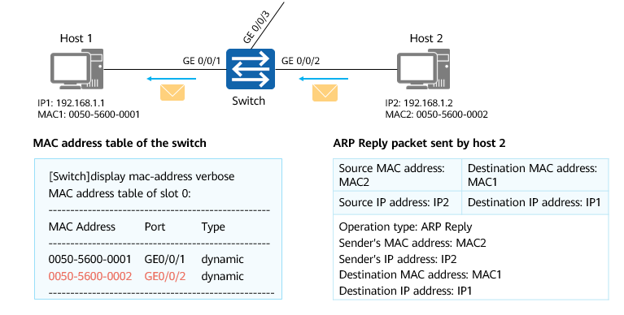

Reply of the target host

After receiving the ARP Request packet, host 2 processes the packet and sends an ARP Reply packet to host 1.

After receiving a frame, the switch searches the MAC address table. If the corresponding entry is found in the table, the switch forwards the frame to the corresponding interface and records the source MAC address and interface number of the received frame in the MAC address table.

After receiving the ARP Reply packet from host 2, host 1 records the corresponding IP address and MAC address in its ARP cache table and encapsulates its packets to access host 2.

## Quiz

1. (Single) A Layer 2 Ethernet switch generates a MAC address table entry based on the ( ) of the packet received by an interface.
2. Source MAC address
3. Destination MAC address
4. Source IP address
5. Destination IP address
6. (Single) A switch has eight interfaces. A unicast frame enters the switch through one of the eight interfaces, but the switch cannot find the destination MAC address entry of the frame in the MAC address table. In this case, which of the following operations is performed by the switch? ( )
7. Discarding
8. Flooding
9. Point-to-point forwarding
10. (Single) Which of the following fields is not included in the Layer 2 header? ( )
11. MAC
12. S.MAC
13. IP
14. Type
15. (Single) Which of the following MAC addresses is a unicast MAC address? ( )
16. 00-1E-10-DD-DD-02
17. 01-80-C2-03-02-01
18. 01-00-5E-01-01-01
19. FF-FF-FF-FF-FF-FF
20. (Multiple) What are the forwarding behaviors of switches? ( )
21. Flood
22. Broadcast
23. Forward
24. Discard
25. (True or False) All the interfaces of the hub are in a collision domain, and one interface of the switch is a collision domain. ( )
26. True
27. False

## Summary

This section describes the basic information about the Ethernet protocol, Ethernet frame formats, MAC address, and working principles of Layer 2 switches. Specifically, after receiving a frame, a switch learns the source MAC address of the frame and searches the destination MAC address of the frame in the MAC address table. If the destination MAC address exists in the table, the switch forwards the frame through the corresponding interface.

This course also describes the whole process of data communication within the same network segment based on the working principles of switches.